Git Assignments

(Section 0)

1. Create a project_dir & cd project_dir.
2. Initialize git version database.
3. Create a new file index.html.
4. Check the Git status you should find index.html as an untracked file.

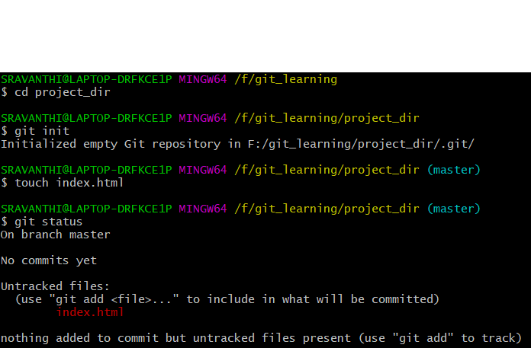

1. Stage the index.html file.

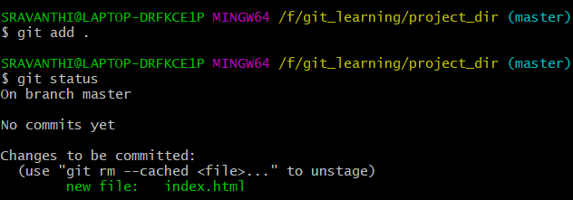

1. Commit index.html file. 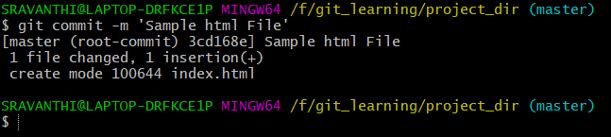
2. Make a few changes in HTML file & create a new info.txt file 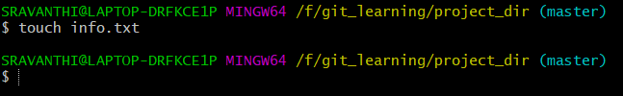
3. Check git status you should find index.html and info.txt as untracked files. 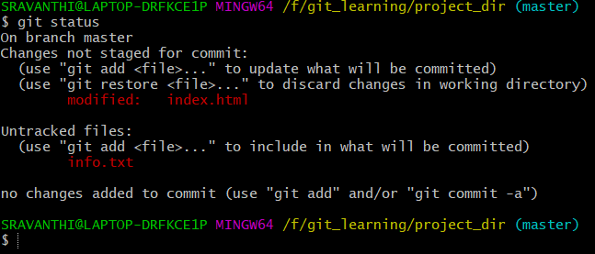
4. Configure git to ignore all text files.  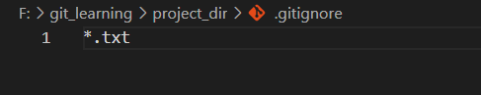
5. Again check git status you should find index.html is an untracked file. 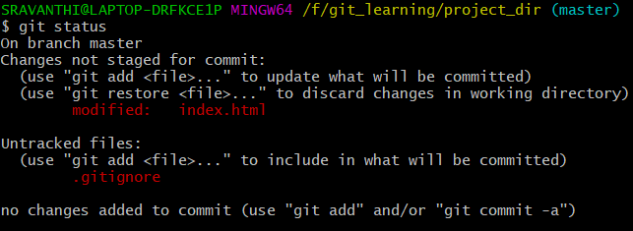
6. State and commit index.html. 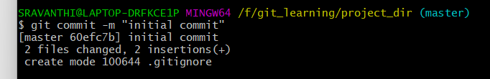
7. Log all your comments so far. 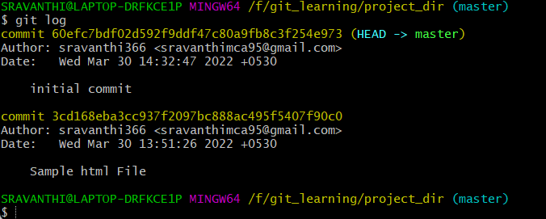
8. Make some changes in index.html file. 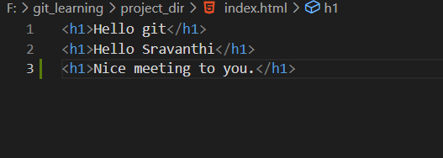
9. Revert the change made in the previous step using the git command. 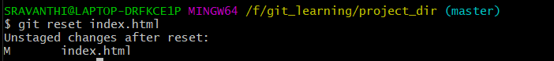
10. Again Change index.html

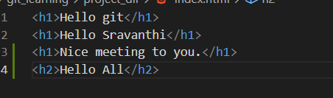

1. Stage index.html.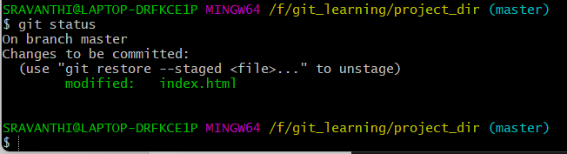
2. Revert back last stage.

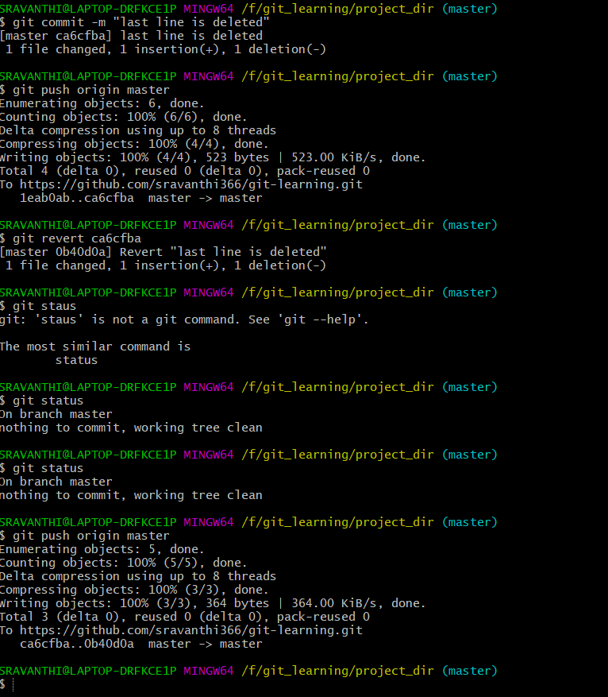

1. Rename add command to my-add.
2. Use my_add command stage index.html again & commit the changes.

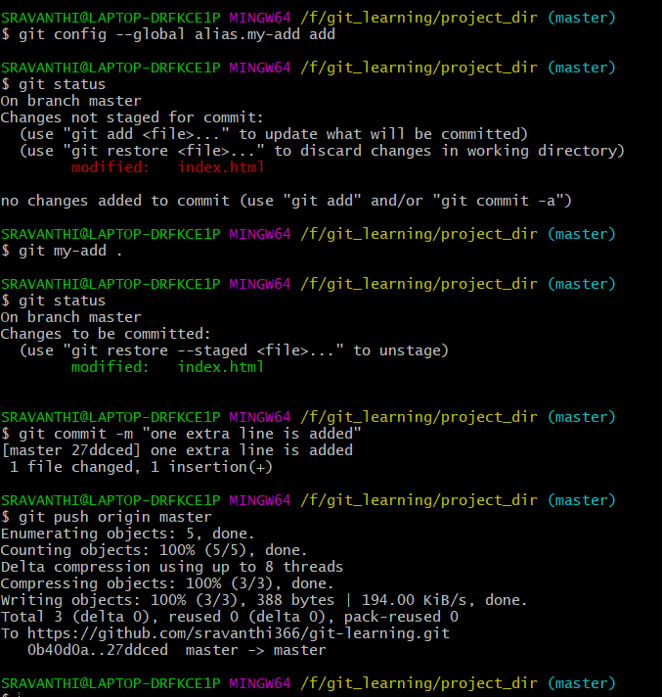

1. Revert the last commit

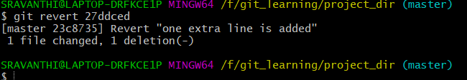

Git Branch

(Section-1)

1. First take a backup of your assignments & projects. This is required because due to in correct git operation we may loose your files.
2. Create an empty directory Assignments & cd Assignments

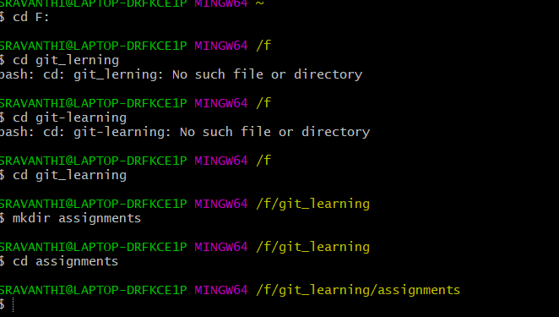

1. Create readme.txt file in assignment folder add some text to read me file

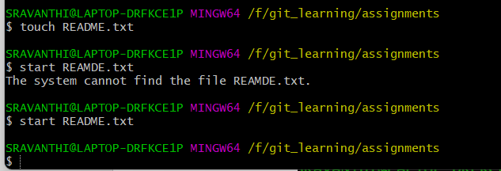

1. Commit Readme.txt file.

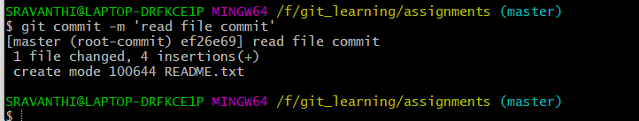

1. Create a new branch from ‘html-assignments’



1. Switch to html-assignments branch.

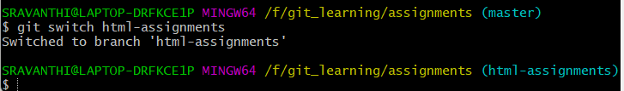

1. Copy all HTML assignments from the assignments folder.
2. Commit html assignments into html-branch.

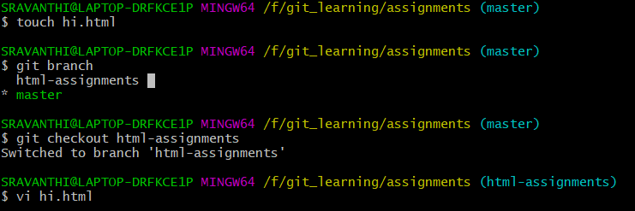

1. Make minor changes into file belonging to html-assignments branch.

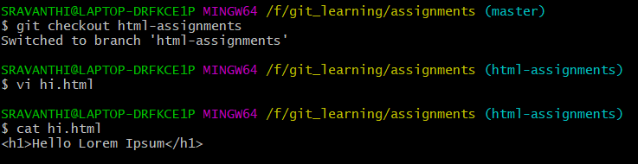

1. Commit those changed files.

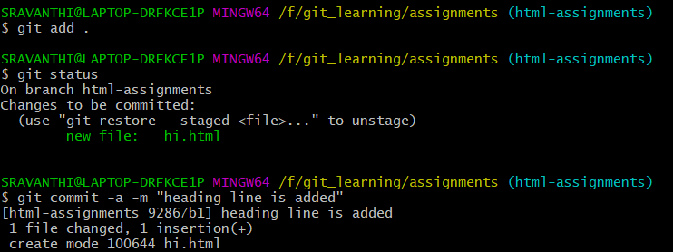31. Switch to the master branch.



32. Make minor changes to the readme.txt file and commit those changes to master.

33. Again switch to the HTML assignments branch.

34. make minor changes to a few lines belonging to the HTML assignments branch.

35. commit those changes.

36. switch to master.

37. merge HTML-assignments branch into master. Confirm all HTML assignments are shown in the master

38. Finally delete the html-assignments branch.

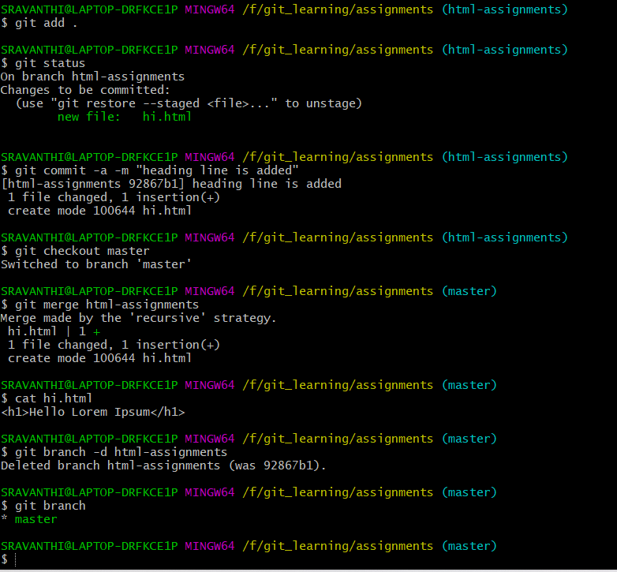

(Section-2)

1. Create a new branch of CSS assignments.
2. Switch to the CSS assignments branch.
3. Copy all CSS assignments inside the assignments folder.
4. Commit CSS assignments into the CSS-assignments branch.
5. Make minor changes to the README.txt file on line 1 belonging to class assignments.
6. Commit those changed files.
7. Switch to the master branch.
8. Make minor changes to the README.txt file on line 3 belonging to class assignments. Commit those changes to master.
9. Again Switch to the CSS assignments branch.
10. Make minor changes and commit those changes in the CSS-assignments branch.
11. Commit changes.
12. Switch to master.
13. Merge css -assignments branch into master.
14. Finally delete the branch. 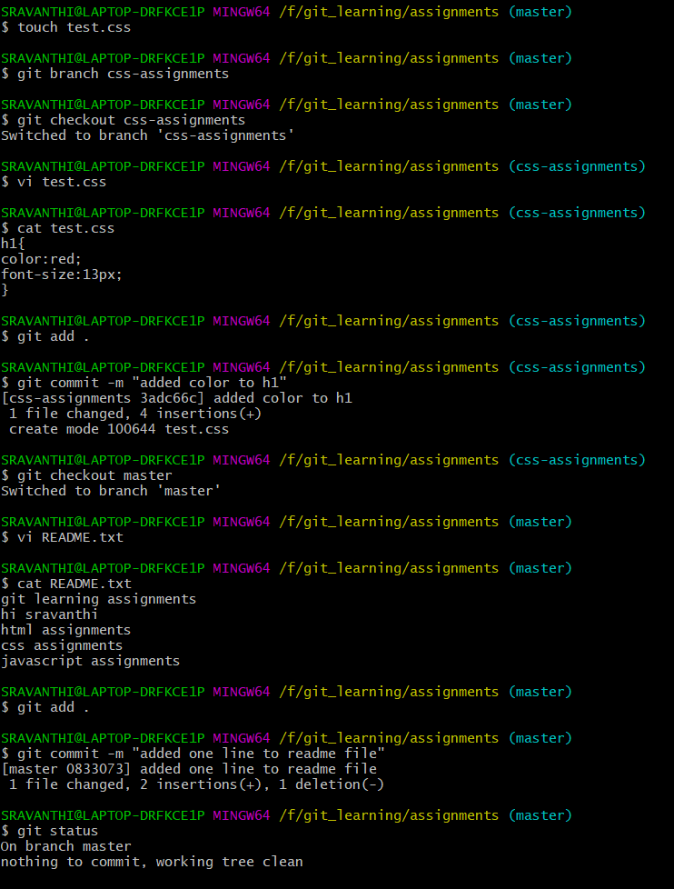 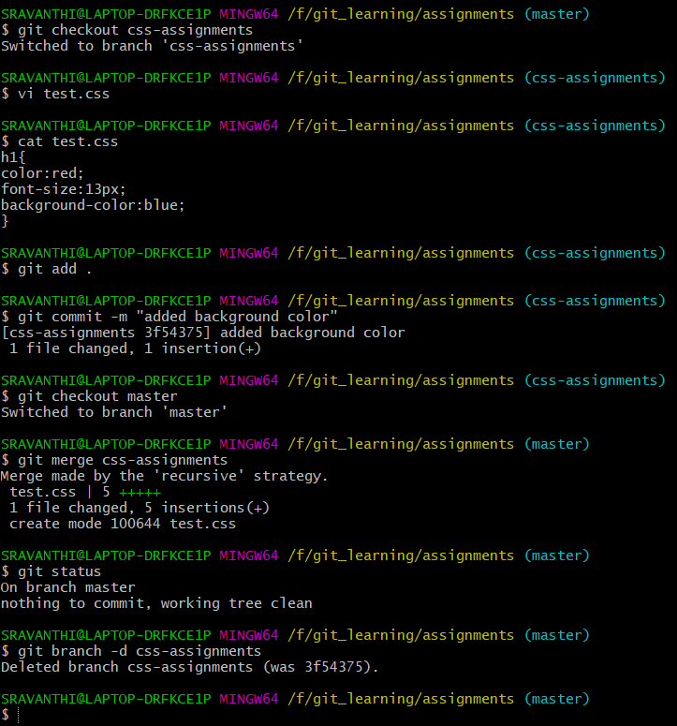
15. Create a new branch of JS assignments.
16. Switch to the JS assignments branch.
17. Copy all JS assignments inside the assignments folder.
18. Commit JS assignments into the JS -assignments branch.
19. Make minor changes to the README.txt file on line 1 belonging to JS assignments.
20. Commit those changed files.
21. Switch to the master branch.
22. Make minor changes to the README.txt file on line 3 belonging to JS assignments. Commit those changes to master.
23. Again Switch to the JS assignments branch.
24. Make minor changes and commit those changes in the JS -assignments branch.
25. Commit changes.
26. Switch to master.
27. Merge JS -assignments branch into master.
28. Finally delete the branch. 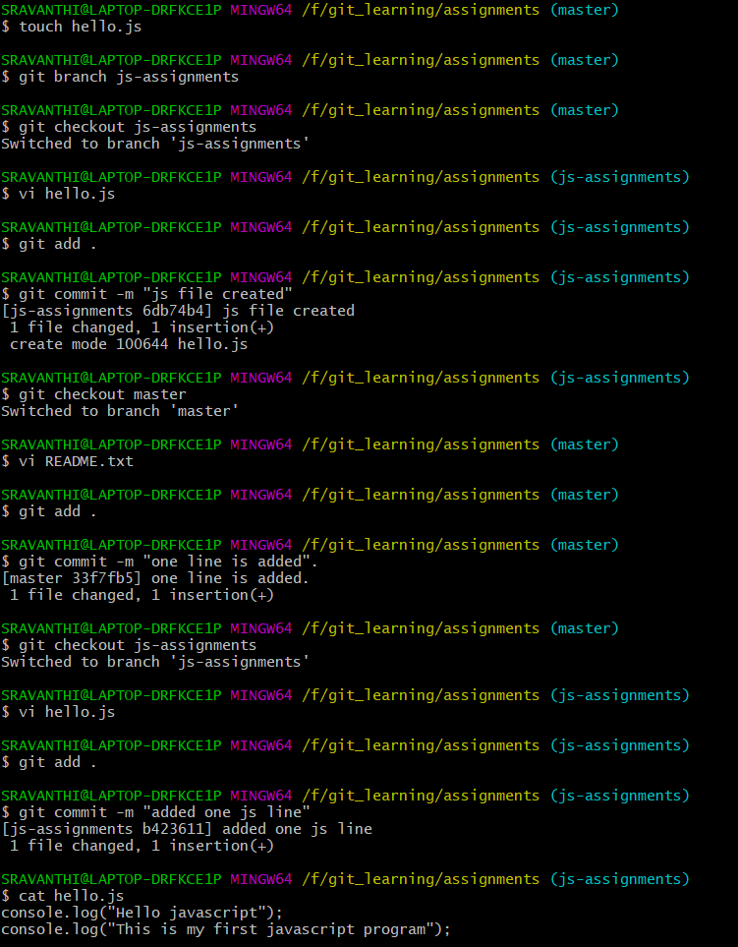

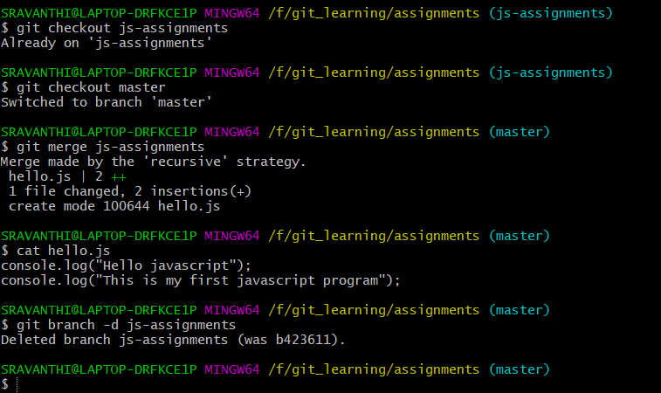

Section 4:

1. Create a GitHub account if you do not have already.
2. Login to github account.
3. Create a new public repository “freshers-batch-march17”.
4. Commit & puch any sample file to this repository under assignments directory.

